Assignment
- Give three functions of endoskeleton.

- The diagram below represents a mammalian bone
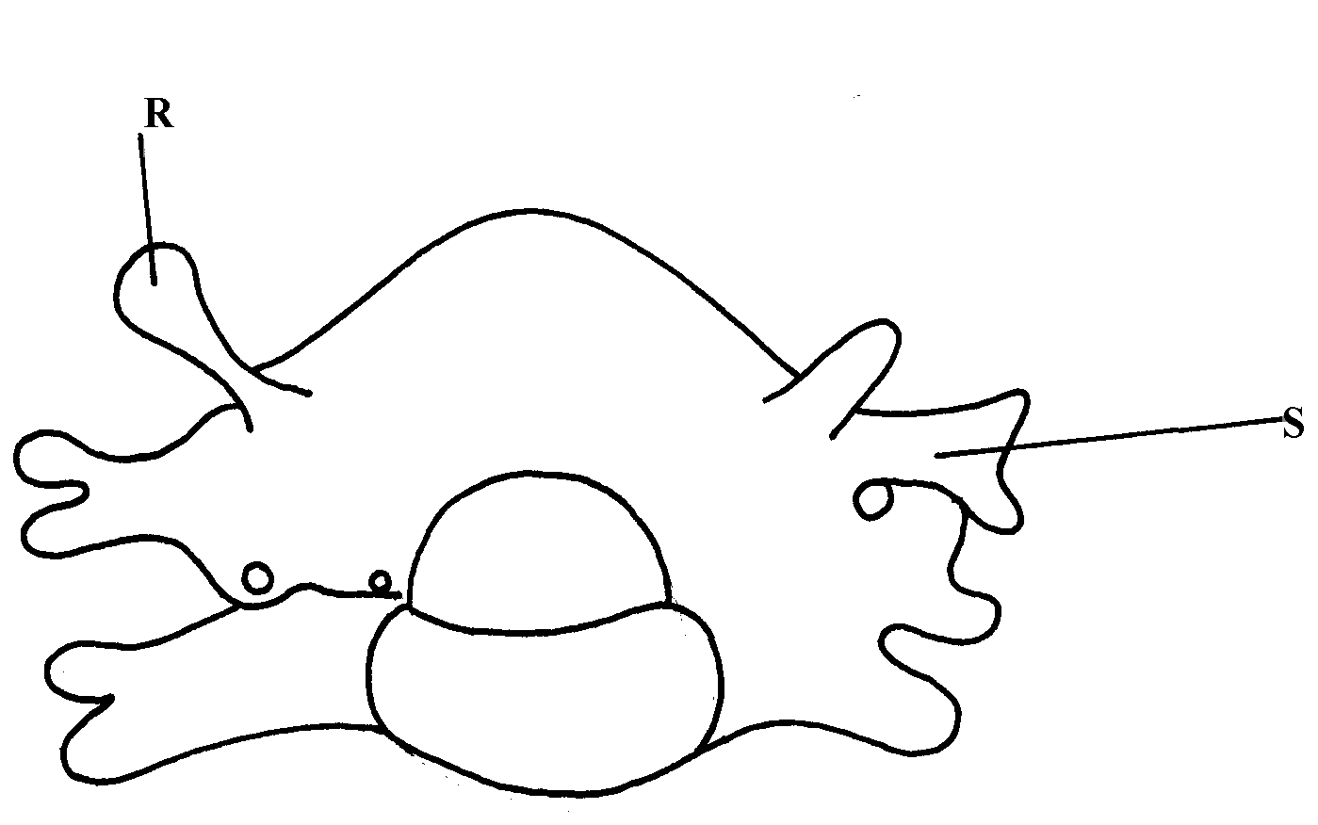

(a) Identify the bone shown above
(b) State the function of the parts labelled R and S
(c) State the region of the body in which the bone is found

- Give two observable differences between lumber vertebrae and thoracic vertebrae.

