c) i) What is mitosis?
- A type of cell division that occurs during growth leading to increase in number of cells
- all cells maintain the same chromosome constitution i.e. the diploid state

ii) Describe the five stages of mitosis
Interphase

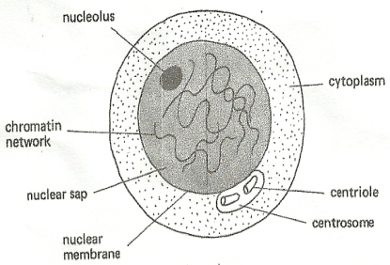
- replication of organelles
- duplication of DNA
- production of energy (ATP) for cell division

Prophase
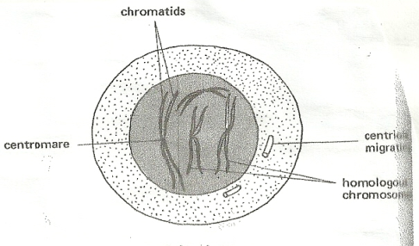
- stage of dehydration
- chromosomes shorten and thicken
- chromosome replicates into two chromatids
- chromatids joined at centromere
- formation of spindle fibers

Metaphase
- chromosomes move to equator (early metaphase)
- chromosomes line up at the equator
- homologous chromosomes do not associate
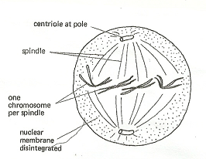

Anaphase
- chromatids separate
- move to opposite ends (poles) of the cell
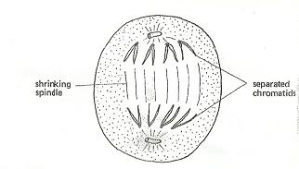

Telophase
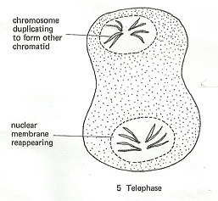

- chromatids reach the poles
- formation of two daughter cells occurs i.e. cytoplasmic division

ii) State the significance of mitosis
- ensures each daughter cell has same number and kinds of chromosomes as daughter cells
- gives rise to new cells (responsible for growth)

